## Observables & RxJS

**Learning Objectives**

* Know what *Observables* are.
* Know what *RxJS* is and how it relates to *Observables*.
* Know what *operators* are, how to find out about the list of operators and how to understand an operators function by using marble diagrams.
* Know how to build a simple application using *RxJS*.

**Observables**

Streams so far are just a *concept*, an idea.

We link streams together using operators, so in in our previous example the add function is an operation, specifically it’s an operation which combines two streams to create a third.

*Observables* is a new primitive type which acts as a *blueprint* for how we want to create streams, subscribe to them, react to new values, and combine streams together to build new ones.

It’s currently in discussion whether or not Observables make it into the *ES7* version of JavaScript.

We are still trying to roll out ES6 so even if it makes it, it will be many years before ES7 becomes something we can code with natively.

Until then we need to use a library that gives us the *Observable* primitive and that’s where *RxJS* comes in.

**RxJS**

*RxJS* stands for *R*eactive E*x*tensions for *J*ava*S*cript, and its a library that gives us an implementation of Observables for JavaScript.

 Observables might become a core part of the JavaScript language in the future, sowe can think of RxJS as a placeholder for when that arrives.

RxJS is the JavaScript *implementation* of the ReactiveX API, which can be found [here](http://reactivex.io/).

The API has *multiple* implementations in *different languages*, so if you learn RxJS you’ll know how to write RxJAVA, Rx.NET, RxPY etc…

### Library

Let’s explain RxJS by working through a simple example.

To reduce file size the RxJS library is broken up into many different parts, one main one and one for each operation you want to use.

For our example we’ll add the rx.all.js library which contains *all* the operators.

We create a simple index.html file and add the rx.all.js library in via a script tag.



In Angular since we are using modules we’ll be adding in RxJS using

import

statements. We are using script tags here just for simplicity of setup.

<!

DOCTYPE html

>

<

html

>

<

head

>

<script src="https://cdnjs.cloudflare.com/ajax/libs/rxjs/4.1.0/rx.all.js"></script>

<script src="main.js"></script>

<

/head

>

<

body

>

<

/body

>

<

/html

>

We also create a main.js where we will start adding our RxJS code.

### interval

The first thing we need to to is get an instance of an RxJS Observable, we do this like so:

let obs = Rx.Observable;

An observable **isn’t** a stream. An observable is a *blueprint* which describes a *set* of streams and how they are connected together with operations.

I want our observable to create a *single* stream and push onto that stream a number every second, incremented by 1.

With RxJS to define an observable to achieve the above we would use the operator interval, like so:

let obs = Rx.Observable

.interval(1000);

The operation interval takes as the first param the number of milliseconds between each *push* of the number onto the stream.

In RxJS operators act on an observable and return an observable with the operator applied, so we can chain operators together creating an *Observable Chain*, like so: let obs = Rx.Observable

 .operator1();

.operator2();

.operator3();

.operator4();

.operator5();

### subscribe

 In RxJS land no one can hear you *stream*, unless you subscribe.

This observable is *cold*, that means it’s not currently pushing out numbers.

The observable will become *hot* and start pushing numbers onto it’s first stream, when it gets it’s first *subscriber*, like so:

let obs = Rx.Observable

.interval(1000);

obs.subscribe(value => console.log("Subscriber: " + value));

By calling

subscribe

onto an observable it:

1. Turns the observable *hot* so it starts producing.
2. Lets us pass in a callback function so we react when anything is pushed onto the *final stream* in the observable chain.

Our application now starts printing out:

Subscriber: 0

Subscriber: 1

Subscriber: 2

Subscriber: 3

Subscriber: 4

Subscriber: 5

Subscriber: 6

Subscriber: 7

Subscriber: 8

Subscriber: 9

Subscriber: 10

### take

But it just keeps on printing, forever, we just want the first 3 items so we use another operator called take.

We pass to that operator the *number of items* we want to take from the first stream. It creates a second stream and only pushes onto it the number of items we’ve requested, like so:

let obs = Rx.Observable

.interval(1000)

.take(3);

obs.subscribe(value => console.log("Subscriber: " + value));

This now prints out the below, and then stops:

Subscriber: 0

Subscriber: 1

Subscriber: 2

### map

Finally I want to add another operator called map, this takes as input the output stream from take, convert each value to a date and pushes that out onto a third stream like so:

let obs = Rx.Observable

.interval(1000)

.take(3)

.map((v) => Date.now());

obs.subscribe(value => console.log("Subscriber: " + value));

This now prints out the time in milliseconds, every second, like so:

Subscriber: 1475506794287

Subscriber: 1475506795286

Subscriber: 1475506796285

**Other operators**

The above example showed a very very small subset of the total number of operators available to you when using RxJS.

The hardest part of *learning* RxJS is understanding each of these operators and how to use them.

In that regard even though you are writing in JavaScript learning RxJS is closer to learning another language altogether.

You can find a list of the operators by looking at the official documentation [here](http://reactivex.io/rxjs/manual/overview.html#operators).

The documentation for the operators we just used above is:

* [Interval](http://reactivex.io/rxjs/class/es6/Observable.js~Observable.html#static-method-interval)
* [Take](http://reactivex.io/rxjs/class/es6/Observable.js~Observable.html#instance-method-take)
* [Map](http://reactivex.io/rxjs/class/es6/Observable.js~Observable.html#instance-method-map)

### Marble Diagrams

Trying to understand an operator by just reading some words is pretty difficult.

This is why in this lecture I’ve tried to use animations as much as possible.

The Rx team use something called a *marble* diagram to visually describe an operators function.

This is the official marble diagram for the map operator:

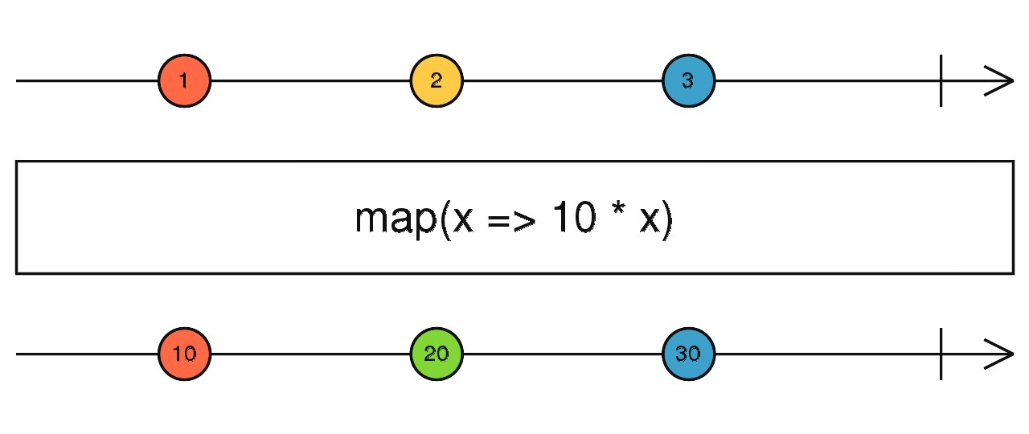

* The line at the top represents *time* and the *marbles* with numbers 1, 2 and 3 represent the *input* stream over time.
* The line at the bottom represents the *output* stream after each of the marbles has been processed through the operator.
* The bit in the middle is the operator, in this example the operator is a map function which multiplies each *marble* in the input stream by 10 and pushes them to the output stream.

So in the above the value 1 gets pushed out onto the output stream as 10.

These diagrams are actually *interactive*.

To understand how an operator works we move the marbles around in the input stream and see how this affects the output stream, like so:

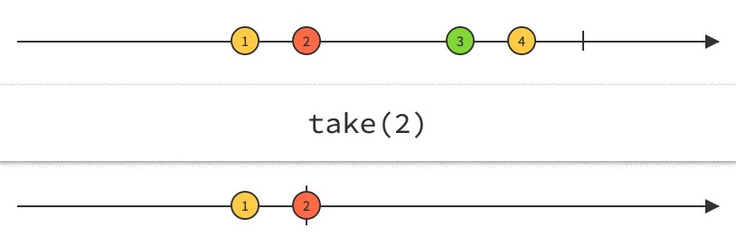

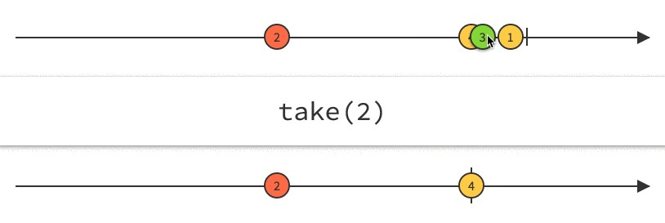

*Marbles* for the above operators are [Take](http://reactivex.io/documentation/operators/take.html) and [Map](http://reactivex.io/documentation/operators/map.html)

**Summary**

*Observables* are a blueprint for creating streams and *plumbing* them together with *operators* to create *observable chains*.

RxJS is a library that lets us create and work with observables.

We can *subscribe* to an observable chain and get a callback every time something is pushed onto the *last* stream.

By default observables are *cold* and only become *hot* when they get their first subscriber.

Learning RxJS involves understanding all the operators that are available and how to use them together.

We use marble diagrams to help explain how an operator works.

In this lecture we used RxJS in isolation, in the next lecture we will look at how to use RxJS in Angular.

**Listing**

<http://plnkr.co/edit/jfs3Y2WcXXGPVPsS5BM9?p=preview>

*main.js*

let obs = Rx.Observable

.interval(1000)

.take(3)

.map((v) => Date.now());

obs.subscribe(value => console.log("Subscriber: " + value));

*index.html*

<!

DOCTYPE html

>

<

html

>

<

head

>

<script src="https://cdnjs.cloudflare.com/ajax/libs/rxjs/4.1.0/rx.all.js"></script>

<script src="main.js"></script>

<

/head

>

<

body

>

<

/body

>

<

/html

>